**LAB**

**NAME : V Vishwa**

**REG NO : 192421374**

**COURSE CODE : CSA1423 - Compiler Design**

**EXPERIMENT 3**

Develop a lexical Analyzer to test whether a given identifier is valid or not ?

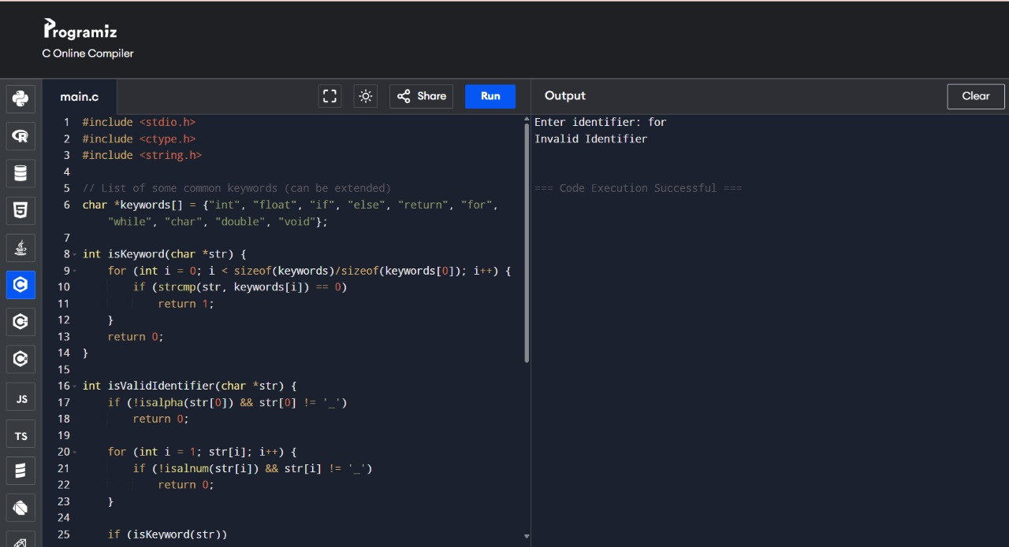

**EXPERIMENT 4**

Implement a C program to eliminate left recursion?

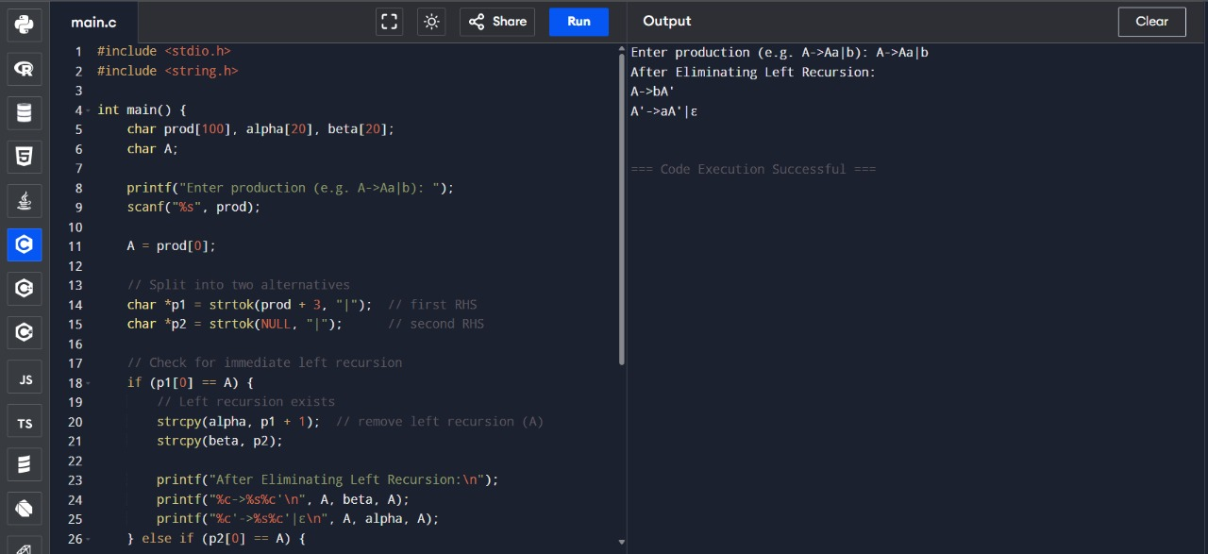

**EXPERIMENT 5**

Implement a C program to eliminate left factoring?

